10. Tuning of autoISF settings for Full Closed Loop aided by the Emulator V.2.3 for 301

Please note that with autoISF you are in an early-dev. environment, where the user interface is not optimized for safety of users who stray away from intended ways to use. Good safety features exist, but these are only as good as the development-oriented user understands and implements them. This is not a medical product, refer to disclaimer in section 0

Available related case studies:

Case study 10.1:

Based on older autoISF and older Emulator versions, examples from emulator use can be found in case study 6.2, in case study 4.1 (last pages there), and case study 8.2
10.1 Installing the Emulator on your PC
10.2 Analyzing loop decisions in logfiles
10.3 What-if analysis

You can set up and tune the system for full closed loop as described in previous sections. Doing this by frequently analyzing screenshots that must be taken in real-time of the AAPS SMB tab is tedious, however.

More elegant and precise tuning can be done with a special evaluation software for the AAPS logfiles, by using the Emulator.

In the Emulator, you can see in tabular and graphical form, which autoISF component contributed to SMB values that determined the glucose curve.

Note that iOS based variants of autoISF (in iAPS or Open iAPS) can not use the Emulator. Refer to section 11.3.

10.1 Installation of the emulator on your PC

10.1.1 First dowenload QPython3L onto your PC. Then download from: https://github.com/ga-zelle/APS-what-if/blob/A3.2.0.4_ai3.0.1_dev/software :
each of these 5 py resp. config. files. To do this, you must press, for each one, here e : : ……………………………..
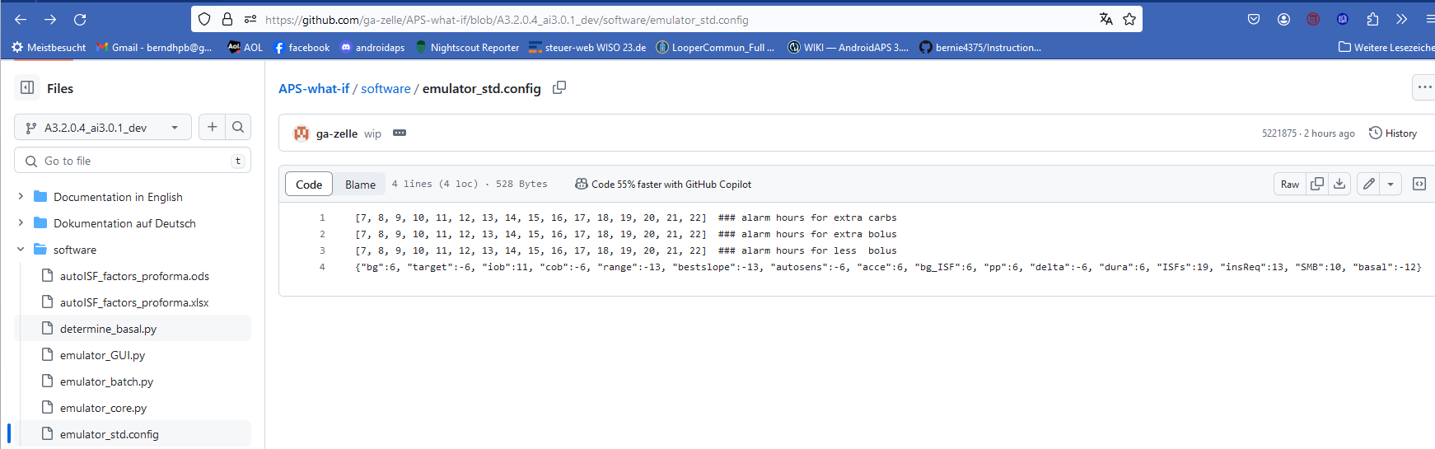

    - Retrieve these 5 downloaded files on your PC (list of recent downloads), and shift them into a folder in which, or neighboring to which, you also keep your AAPS logfiles. (These you must copy about once a week from your phone )
    - One of these 5 files is “emulator_GUI.py“. Create a link to it, and drag that link onto your desktop. Name it something like Emulator start.

    - Repeat steps 10.1.1. and step 10.1.2. for 2 more py files from https://github.com/ga-zelle/Scan-APS-logfiles/blob/main and download also these:
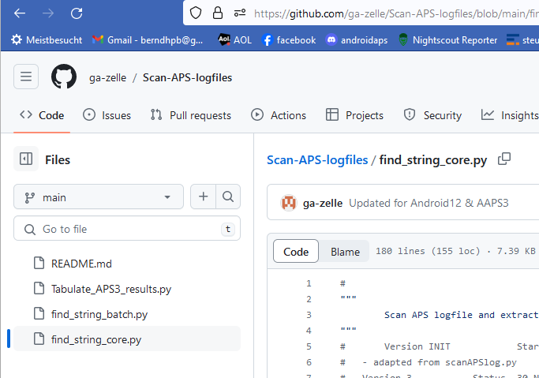
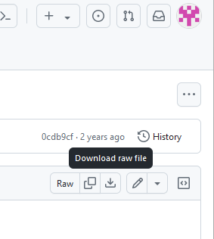

  - Read and analyze logfiles with help from the emulator
10.2.1 Set up a “no change” (empty) vdf file (Note: for what-if analysis, more entries will be made in vdf later, see section 3)
To do this, just open Notepad++ (from list of all programs on your PC). Store that in a file of your current emulator project you are about to start (see my storage path in top line here)
The no change .vdf should look like something like this:
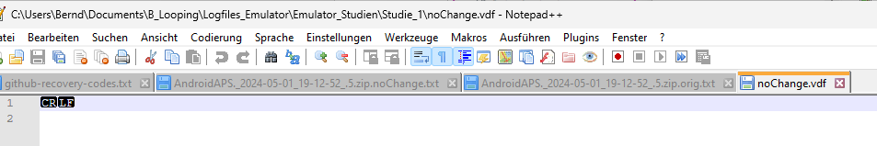
Erase any entries after CR LF and also in lines 2 ff, if any

10.2.2 Make sure you have the AAPS logfiles you might want to analyze in a immediate neighboring file to your project file (as example given headline shown in 2.1)

10.2.3 Now go to your PC desktop, and start the emulator by just pressing the button you installed in step 10.1.3
This opens a big dialogue box with 3 fields that you must fill in with the applicable path (without any quotation marks “..”) from your explorer (file system):
- The top box marks the path to your current emulator project (where you want to store results)
- The middle box marks the path to your current vdf (what kind of analysis; here: read-only; se section 3 for what-if)
- The third box marks the path to your AAPS logfiles you wish to look into

(screen)

At the bottom, you get the opportunity to limit the analysis to specified days, and times of day, within these logfiles

10.2.4 Press “Run emulation”.
This produces sometimes an error message (in which case you must seek help, in the Github materials provided by ga-zelle, or in Discord/Full-Closed-Looping/emulate-aaps here: https://discord.gg/n3tD5eXExC

What should come up is results, which you can look into in a couple of ways.

10.2.4.1 Tabular presentation of how parameters like bg, iob, iobTH, the various ISF contributors, bg target and insulinRequired etc. develop every 5 minutes, and what SMB size and %TBR resulted.

      - Best copy the entire table into a new Excel sheet where you can :

* add right next to the standard world time your time zone’s time. For instance, adding +2/24 translates the UTZ column into central European winter time column next to it (where currently a row of Z stands). Likewise, in summer (?), substract like -5/24 from UTZ for an US East Coast time scale. Highlight all time fields and switch from hh:mm:ss format to hh:mm

* hide any column you find less important to look at for your intended analysis

* hide lines (time segments) you find less important to look at for your intended analysis
Recommendation is to hide, not erase, so you can easy pull up more again, and also “boxes” (data fields) retain their original position in both tables

Usually you will color mark where relevant SMBs were given, which of the ISFs (and underlying weights) was strongly contributing (note that this can be good or not good) . Also where iobTH was exceeded, whether an Automation kicked in e.g. setting a TT, when there were periods with zero insulinRequired.

You may be able to formulate a hypothesis or two, what settings (…ISF_weights, iobTH%, SMB_range_extention, autoISFmax …) should be changed for improvement (then go to 10.3)
      - Text of all SMB tab info

Where, example

Search options (see case study ….)

      - Last graph
Example

  - Do what-if analysis using the emulator

    - Constructing the vdf file for your query

    - Execute analysis and analyze tabular results

    - Besides the results from the run with set parameters, there are columns that show how each single decision would differ if the (set of) different parameters as per vdf file would have been used. Note that you can see in which situations the new setting would have had a big impact.

Complicatiomns:
- Often you will see a desired effect in one point of time, but new problems in other parts of the bg curve. Then a more detailed data analysis is required, how the changed setting(s) influence different aspects, and could receive an overall better balance via setting different …_ISF_weights, iobTH_percent, or other parameters.
- As any noticeably different decision will inevitably change the bg curve, the result of a change can never be fully predicted. It needs to be verified experimentally. As an intermediary step, running what-if with speech synthesis real time on the smart-phone (section 11.2) can be a great idea.

Work in progress, to be continued

